
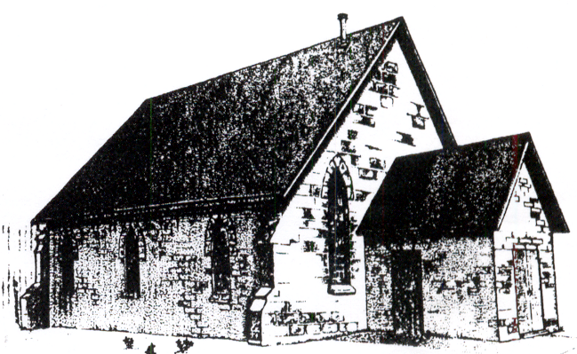
St. John’s Anglican Church
10009 Guelph Line
R.R. 1 Nassagaweya
Campbellville, Ont. L0P 1B0

Upon approval, a Bereavement Authority of Ontario endorsed copy will be available.

NOTICE FOR THE BY-LAWS

Notice dated 16th January 2023

St. John’s Anglican Church Cemetery Nassagaweya.

St. John’s Anglican Church has submitted by-laws to the Registrar of the Funeral, Burial, and Cremation Services Act, 2002. Any interested parties may contact Susanne Baker the Operator’s Representative, at Tel: (519) 766-1458 for information, or to make copies. By-laws or amendments may be reviewed or copied, by appointment, at:-
The Church Office
St. John’s Anglican Church
10009 Guelph Line RR1 Nassagaweya.
Campbellville. L0P1B0

These by-laws are subject to the approval of the Registrar, Funeral, Burial, and Cremation Services Act, 2002. Telephone: Bereavement Authority of Ontario 647-483-2645 or 1-844-493-6356

STJ/smb/2023Jan16

